**PYTHON CODING CHALLENGE – 16/04/2025**

Coding Challenge: **Insurance Management System**

TABLES CREATED:

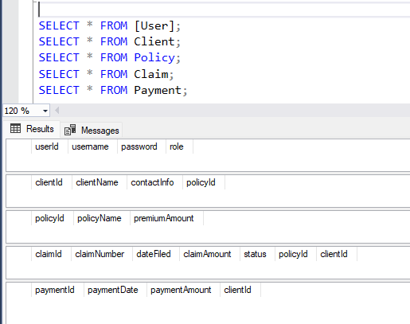

MAIN MODULE EXECUTION:

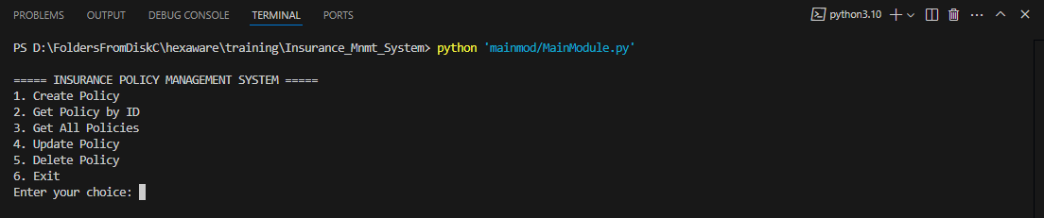

1.Create Policy

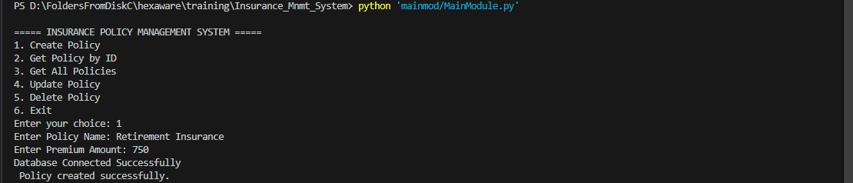

DATABASE UPDATE:

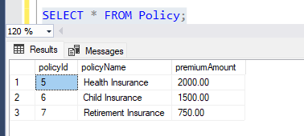

2.GET POLICY

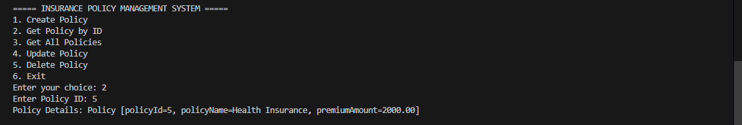

3. GET ALL POLICIES

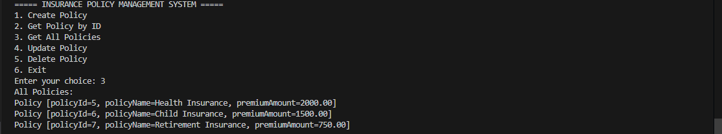

4.UPDATE POLICY

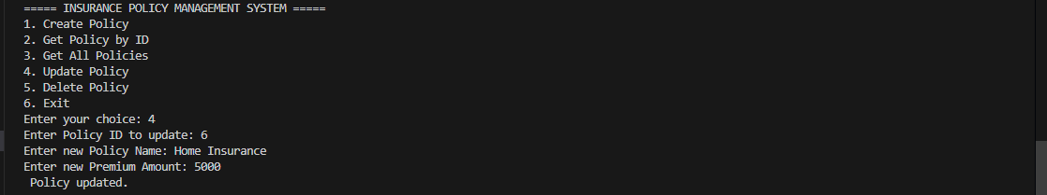

TABLE:

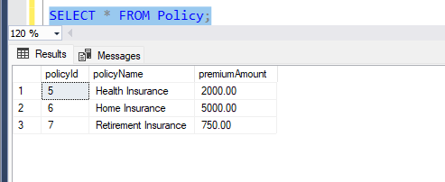

5. DELETE POLICY

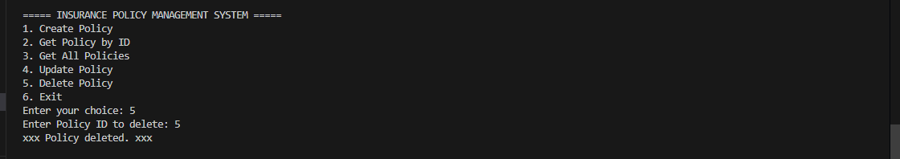

TABLE:

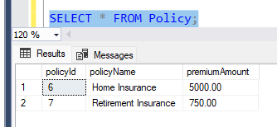

6. CUSTOM EXCEPTION

